**Top-Down Analysis:**

Screenshot of running code:

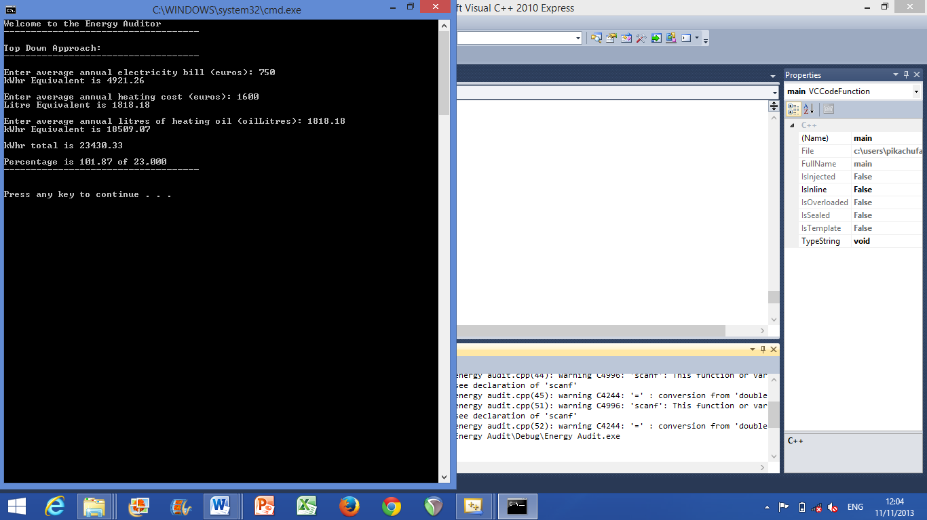

**Summary of findings:**

From writing this code and running it I was able to calculate the average electricity bill per annum to equal to 4921.26 kWhrs.

I also calculated the average heating oil bill of kerosene to equal 18509.07 kWhrs.

When these two figures were added the total for the house per year came in just over the national average of 23,000 kWhrs.

The final figure was 101.87% of 23,000.

So, based on an average electricity bill per annum and given the current rates my home is just over the national average for electricity usage.